SUNDAY 1ST OCTOBER 2023 FROM 12.30 PM TO 6.00 PM

Cumbria Amenity Trust Mining History Society (CATMHS)
Mineral Display

Members of the Society are hosting a mineral display in the Wesley room at Ambleside Parish Centre. This is a rare opportunity to see beautiful specimens collected mainly from mines in Cumbria and Weardale, one of areas traditional industries which helped shape it as it is today. There is the opportunity to discuss, understand minerals and their formation.

Entry free with Tea & Coffee provided. Donations welcome in aid of Ambleside Parish Centre.

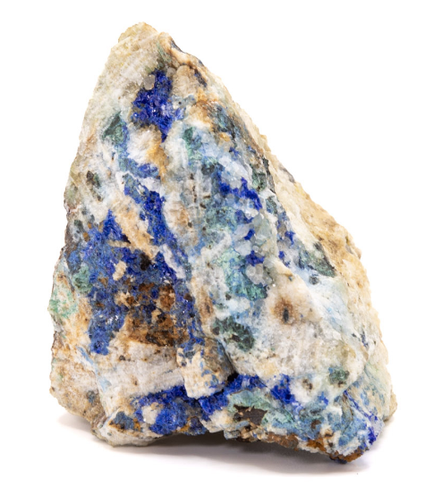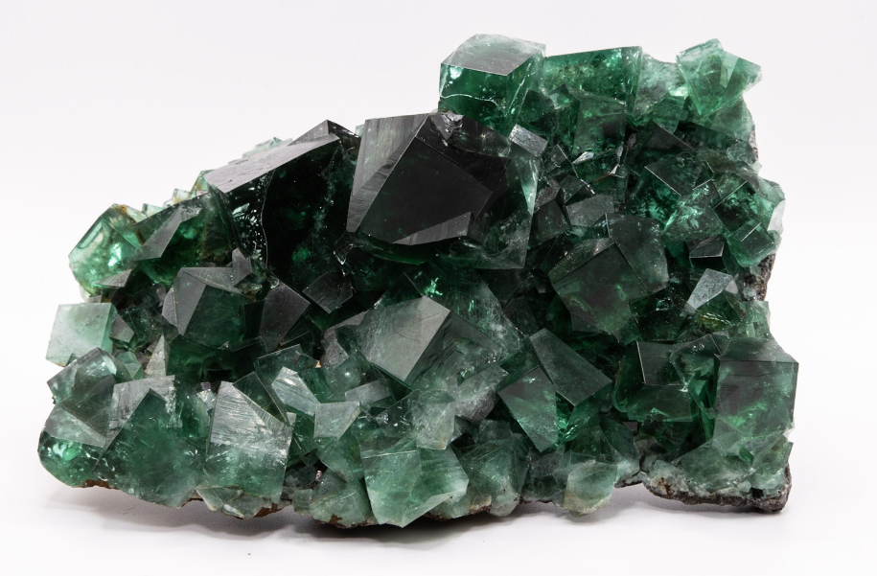
Linarite- Red Gill Mine, Caldbeck Fluorite- Rogerley Mine, Weardale

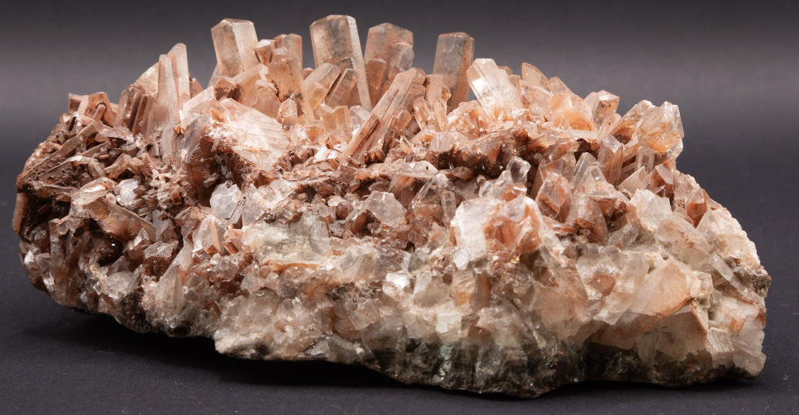
Calcite- Florence Mine, Egremont

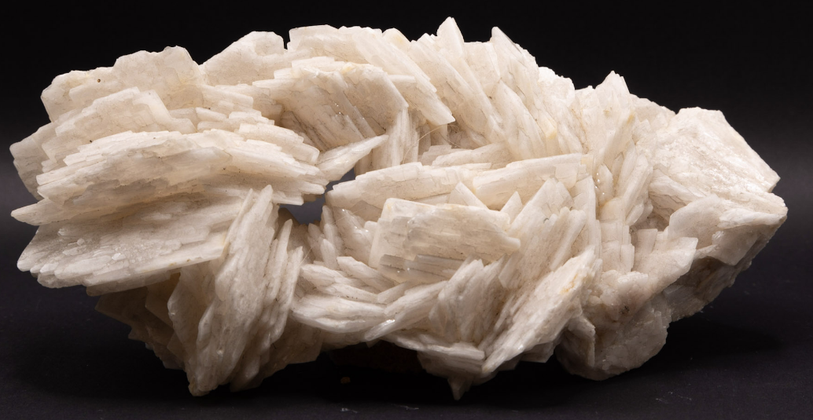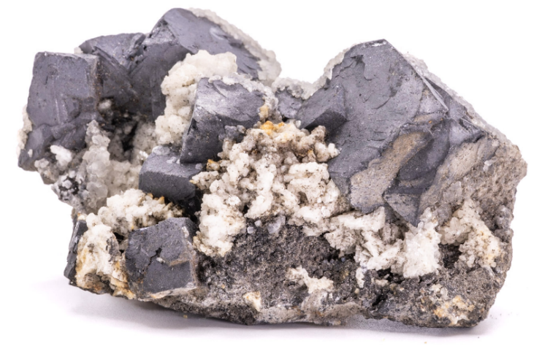
Barytes- Force Crag Mine, Keswick Galena & Dolomite- Smallcleugh Mine, Nenthead

Anyone is welcome to bring their mineral specimens along to show and have them photographed.

